Spanish Cultural Fiesta
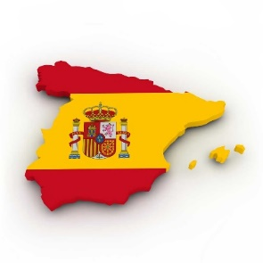
Thursday the 12th of October is National Spanish Day in Spain and Werribee Primary School will be holding a Spanish Cultural Fiesta to celebrate our Spanish language and culture program.
Students will have the opportunity to pre-order traditional Spanish paella and churros for lunch, Foundation students will experience Spanish face painting and Years 1-6 will be able to participate in a Spanish Flamenco dance incursion.
Our specialist program will focus on Spanish throughout the week, with students experiencing different types of Spanish music, dance and games, different Spanish foods and Spanish art and artists.
Students will be introduced to a variety of Spanish outfits and encouraged to come to school in Spanish dress-up for the day.
- - - - - - - - - - - - - - - - - - - - - - - - - - - - - - - - - - - - - - - - - - - - - - - - - - - - - - - - - - - - - - - - - - - - - -
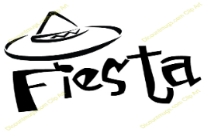 | WERRIBEE PRIMARY SCHOOL  SPANISH DAY SPECIAL FOOD ORDER  Thursday 12th October
PRE PAID – LUNCH ORDER FORM
Note: All orders to be returned by 10am Friday 15th September with payment

First Name: _____________ Surname: _________________ Class: ________
Please mark below to indicate what your child would like to order for Spanish Fiesta Day Lunch
*Vegetarian option is also suitable for Vegans (No animal products in any of the vegetarian ingredients including condiments). All paella's are Gluten Free and DO NOT contain any nuts, and only Spanish Extra Virgin Olive Oil is used.
Paella is a Spanish fried rice dish and Churros are a Spanish donut.
Items for Sale | Price | Qty Required | Total
Chicken Paella | $3.50
Vegetarian Paella | $2.50
Churros with chocolate (1) | $1.00
Total Payment:

